CA267 Week 8 - Lab Materials – Instructions:

Beech Hill Library Project - Project Aims:

Beech Hill (primary and secondary) school has 800 students and a teaching staff of 50.

The library is open to the students all day during school hours and is currently operated by the English Department teaching staff on a rotation basis.

Providing an engaging library experience for students with diverse age, skill and competency levels is not easy. In installing a new library system it is envisaged that the students will be able to enjoy an intuitive, friendly and effective interaction with the wealth of information the library has to offer. This software solution must enable the library provide students with a positive and educational library experience.

The new library system will streamline library operations and improve the day-to-day efficiency of the staff. The school also wants to provide students, parents and educators with an affordable, easy-to-use, integrated software solution which will provide for effective management of the library. The solution will support the teachers and learners alike in making the most of the available learning resources - with access to information leading to learning and achievement.

The school require a computer based system that all teachers will be able to use and utilise in helping their students’ access all library items. Records of books, multimedia materials and the like are tracked through the system to determine usage, availability and requests to reserve items.
The main functions of the system are outlined in the diagram below:
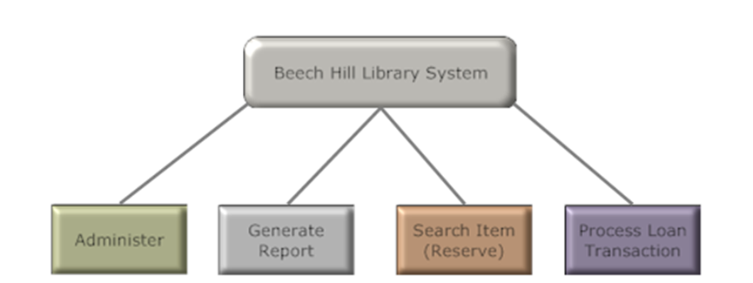
Figure 1- Beech Hill Library System Main Functions

Scenario:
Work in pairs - Work through the following tasks together.
Note: If the task doesn’t specify the role that should work on the task then you should both work on it and should do so from the perspective of the test analyst.
Task 1.
One of you is working as a developer on the Beech Hill Library System and one of you is working as a Tester. As the developer, your manager has asked you to suggest three software development lifecycles that could be used for the development of the system. Work with the tester to provide a description of each of the three approaches and to explain to the manager how the approach taken to testing will differ depending on the approach that has been chosen. Which approach would you recommend and why?
Task 2.
One of you is working as a developer on the Beech Hill Library System and one of you is working as a Tester. Explain the types of skills and mind-set that would be ideal for each of the roles. As the tester, you have found a defect. Explain how you would communicate the defect to the developer. As the developer, explain how you might react. Explain the issues that may be encountered if a developer tests their own code or a tester runs their own tests. Suggest a better approach using the Beech Hill system as an example.
Task 3.
You are both developers working on the Beech Hill Library system. Your manager has advised that you will be using Pair Programming on this project. Explain what is meant by this approach. Do you agree with the Manager decision to use Pair Programming for this project? Explain your rationale. As a team discuss your expectation for how Pair programming will work on this project and the roles involved. What might go wrong and how might you address it? What might go right?
Task 4.
You are both working as testers on the Beech Hill Library System. Your manager has read about low formality testing techniques and thinks that they shouldn’t be used on the project. Explain to your manager how and when these techniques may be beneficial and work together to make a plan as to how they could be incorporated into the test plan for the Beech Hill Library system.
Task 5.
You are both working as developers on the Beech Hill Library system and have been tasked with completing the component testing of the system. Explain what takes place during this phase. Explain how stubs and drivers might be used during this phase of testing. Explain what is meant by integration strategy. Which integration strategy would you suggest if used for the Beech Hill Library system and why? Your manager thinks that some Alpha testing of the system should be planned. Do you agree with this decision and why?
Task 6.
You are both working as testers for the Beech Hill Library System. Your manager is unsure of the difference between White Box and Black Box testing techniques. Explain the difference between the two approaches. Which of the techniques do you think would be most effective for the Beech Hill Library System and why?
Task 7.
In the Beech Hill Library system, a student’s profile includes their age. In order to ensure that the books are appropriate to the students reading level, books are put into categories based on age. The categories are as follows:
- Aged 4 – 8
- Aged 8 – 12
- Aged 12 – 18
- Aged 18 and over

- Using Equivalence Class Partitioning, explain what tests you would run based on testing these age categories.
- Using Boundary Value Analysis, explain what test cases you would run based on testing these age categories.
- Your manager thinks that only one of these techniques is needed. Are they correct in thinking this? Explain your rationale. If choosing one of the techniques which would you choose and why?
- What other tests might be needed here? Any other information you might want prior to testing this part of the system?

